iLab Billing Events Standard Operating Procedure

Creating a Billing Event
https://help.ilab.agilent.com/37451-billing/266667-overview
- Go to the Billing tab within the core’s page in iLab and click the “New Billing Event” button:
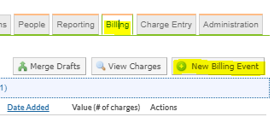
- Select the end date for the charges. This will pull any charges that have not yet been part of a billing event, are marked as “Ready to Bill,” and have a purchase date prior to or the same as the end date selected.
- Enter an appropriate event name.
- Select to include all, internal only, or external only charges, as appropriate.
  - Note: External charges should be included in billing events to mark them as billed in iLab. However, only internal charges will be included in the file transferred to KFS. External charges will need to be entered as Customer Invoices in KFS and sent manually to the external customer contact.
- Click the “Load Charges” button.
- Review the list of billable charges. Look for the following:
  - A red flag under the Status column. This indicated an issue that will prevent this charge from being included in the file sent to KFS. Often this indicates there is no payment information for this charge. To correct, click the symbol under the Payment Information column, select the appropriate account, and click save.
  - A yellow flag under the Status column. This indicates that a charge is not billable. These should be included in the billing event, but the customer will not be charged.
- If a charge needs to be excluded from the billing event you can do so by clicking the symbol next to the charge.
- To view charges excluded from the billing event expand the “Excluded Charges” section. Any charges that are available to be included in the billing event can be added by clicking the symbol.
- Once you have finished reviewing and updating the charges, click the “Save as Draft” button. This will add the billing event to the list under the Billing tab.
- Click the “Edit” button next to the billing event to reopen the billing event.
- If additional charges need to be included in the billing event, click the “Load Additional Charges” button.
- If all charges and ready to be billed and all red flags have been cleared click the “Create Billing File and Invoices” button. This will update the status of the billing event to “Billing Initialized.”
- From Billing tab click the “Summary” button and then click “Send File to Indiana.” This will mark the billing event as ready to be included in the next scheduled data transfer from iLab to KFS. The billing event status will be updated to “Ready to Send.”
- The billing event file will process overnight and the billing event will then be marked as “File sent.” At this point all charges have been posted to the account in KFS. The customer accounts have been billed and the income has been received in the core’s auxiliary account. Charges will show “Not Yet Paid” in iLab unless manually marked as paid, but the transaction has already been completed in KFS.

Refunding a Charge
https://help.ilab.agilent.com/37451-billing/291970-refunds?from_search=63760563
- To refund a charge open the menu in the top-left corner and go to “Invoice” under the Core Facilities section.
- Find the invoice that needs to be refunded in the list and check the Status column. Only invoices marked as “Paid” can be refunded. If the status is “Not Yet Paid” click the “mark as paid” button:
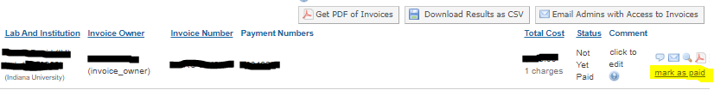
- Once the charged is marked “Paid” click the magnifying glass to open the invoice.
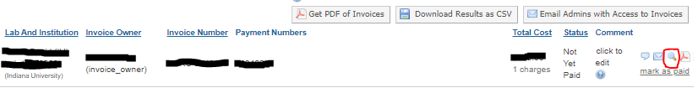
- Hover over the dollar amount of the charge that needs to be refunded. The “Initiate Refund” button will appear – click to initiate the refund:
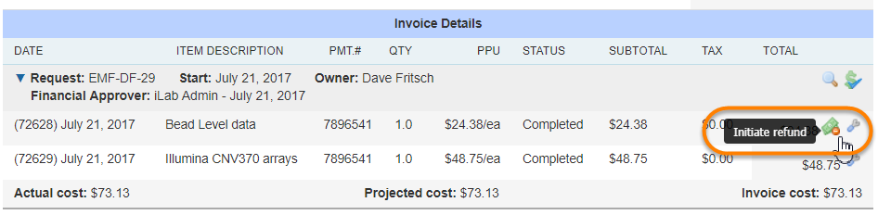
- In the pop-up box select the reason for the refund from the dropdown, enter the quantity to be refunded, and click the “Initiate Refund” button.
- The refund will automatically be marked as “Ready to Bill” and will be available to add to the next billing event.

