iLab Fiscal Officers and Accounts Managers Guide

Contents
iLab Help Resources
Registering for an iLab Account
Navigating iLab
Managing a Lab/Group
Viewing Service Requests
Viewing Invoices
Running Reports
Managing a Department
Approving Fund Requests
Understanding iLab Emails

iLab help Resources

- IUSM iLab page: https://medicine.iu.edu/research/support/service-cores/ilab
  - Link to iLab site
  - FAQs
  - Link to iLab help site
- IUSM iLab Help Desk: iLabIUSM@iupui.edu
- iLab Help Site: https://agilent-ilab.na1.teamsupport.com/dashboard
- iLab Billing Details report: https://tableau.bi.iu.edu/#/site/prd/views/iLabBillingDetails/iLabBillingDetails

Registering for an iLab Account

- Navigate to the iLab registration page for Indiana University.
- Select “Sign in using Indiana University credentials.”
- You will be redirected to IU’s CAS Login page. Sign in using your IU credentials.
- You will be redirected to a page to verify your contact information and choose the iLab lab/group you would like to join. The correct lab will depend on your role:
  - If you will be requesting services on behalf of a PI please select that PI’s lab/group. If you do not see your PI listed select the AAA Default (IU) lab and email iLabIUSM@iupui.edu with the name of your PI.
  - If you will be requesting services on your own behalf (you are the PI of your own accounts) please select the lab/group under your name. If you do not see a lab/group listed under your name select the AAA Default (IU) lab and email iLabIUSM@iupui.edu to request a new lab under your name.
  - If you are a department administrator who will not be working in the system under a specific PI please choose the Staff (IU) Lab and email iLabIUSM@iupui.edu with a brief description of your role in the system.
- Once your registration has been submitted, your PI will receive a notification that you have requested membership.

Navigating iLab

iLab Navigation is through the menu button in the top left corner of the iLab site:

Institution administrators only

- Communications: View iLab notifications
- My Cores: Will only appear for core administrators. Hover to view a list of cores for which you are an administrator.
- Equipment Kiosk: Will only appear for core administrators. Hover to view of list of cores using the iLab Equipment Kiosk functionality.
- View Requests: Click to view services requests submitted by labs you manage.
- View Funds: Click to review fund requests needing your approval.
- My Centers: Will only appear for center administrators.
- Invoices: View invoices billed to labs you manage.
- Reporting: Click to access the reporting dashboard and run reports for labs you manage.
- My Groups: Hover to view a list of your groups (labs).
- My Departments: Will only appear for department administrators. Hover to view a list of your departments.
- My Cores: Will only appear for core administrators. Hover to view a list of your core facilities.
- People Search: Click to search for iLab users.

Managing a Lab/Group

Agilent Help Article
You may access your groups and request access to additional groups by navigating to My Groups in the iLab menu:
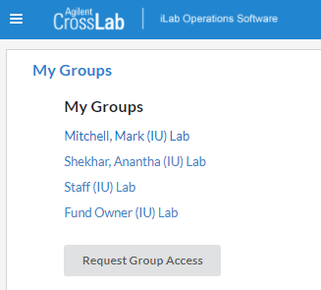
- To request access to a group click the Request Group Access button, choose the Institution “Indiana University,” start typing the PI name or group name and select the appropriate group, then click the Request Access button:
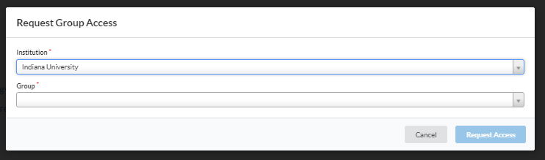
After navigating the lab/group page you will see the following tabs:
- Membership Requests and Accounts: Approve group membership, manage access to funds, request access to funds.
  - Agilent Help Article
- Members: Set financial auto-approval thresholds, adds group members, manage current memberships.
  - Agilent Help Article
  - Roles: PI, Lab Manager (yellow) – similar rights to the PI, financial contact ($ symbol) – receives emails for financial approval requests.
  - Note: If this lab is part of a department the Department managers will show in a separate section under the Lab members and settings table.
- Budgets: Track spending by core members.
  - Agilent Help Article
- Bulletin Board: Post comments and send messages to lab members:
  - Agilent Help Article
- Group Settings: Set group preferences and primary contact.
  - Agilent Help Article

Viewing Service Requests

Agilent Help Article
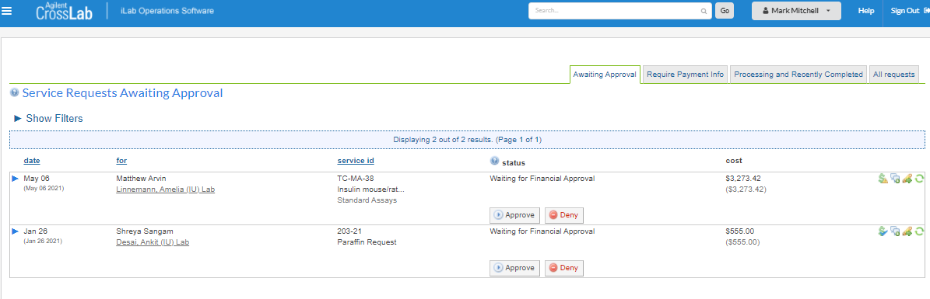
You may access service requests submitted to your lab by navigating to “View Requests” in the iLab menu.
From here you can click the blue arrow next to the charge to view additional details, update payment information, add comments, and view the service request history.

Viewing Invoices

Agilent Help Article
You may view invoices billed to your labs by navigating to “Invoices” in the iLab menu.
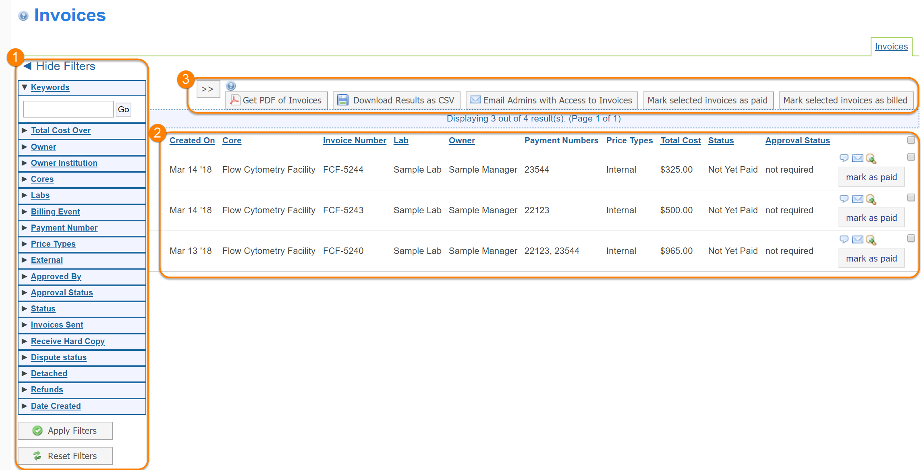
From here you can add comments to the invoice by clicking the text bubble icon and view the invoice details by clicking the magnifying glass icon (for more on the invoice details page see the Agilent Help Article). You may also click the “Bulk Actions” button to download PDF or CSV files with the invoice details.
Note: The email icon and “mark as paid” button are only available to core administrators.
Note: The Status column will likely show the invoice as “Not Yet Paid.” However, invoices are paid as soon as a billing event is successfully transmitted from KFS to iLab. Invoices have to be manually marked as paid in iLab by the core staff, but the funding account in KFS has in fact already been charged.

Running Reports

Agilent Help Article
You may access the Reporting dashboard by navigating to Reports in the iLab menu. From here you can run spending reports on any of your labs.
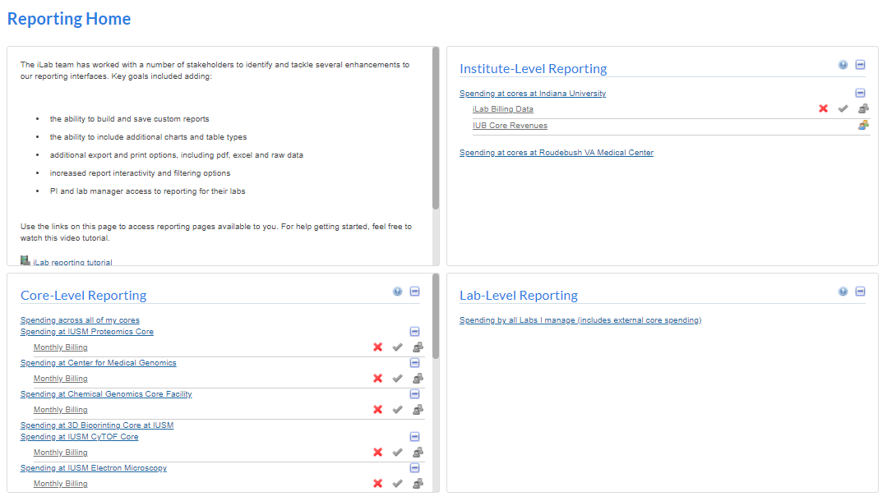
Please review the Agilent Help Article for detailed information on running the lab spending reports.
Accessible only to core administrators
Accessible only to institution administrators

Managing a Department

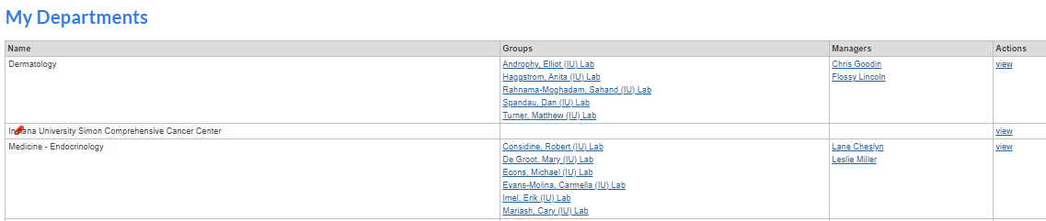
Labs/groups can be organized into departments in iLab. This allows department managers to manage and provide financial approval for labs within the department, without needing to become a member of each lab. If you are a manager of a department, you can access your department by navigating to My Departments in the iLab menu.
From the Departments menu you can view the departments for which you are a manager, the groups within those departments, and the current department managers. To edit the department
click the “View” button.
With the department page you may do the following:
- Add or remove department managers:
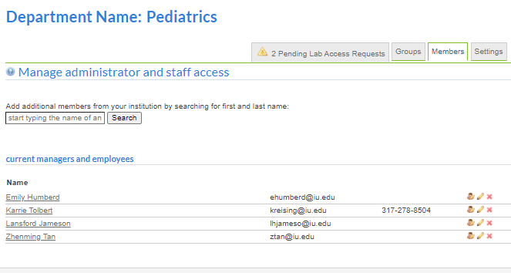
  - To add a manager, type their name in the search box and click the Search button:
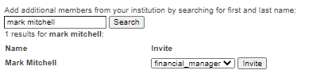
  - To remove a manager, click the red X next to their name.
- Add or remove groups/labs from the department:
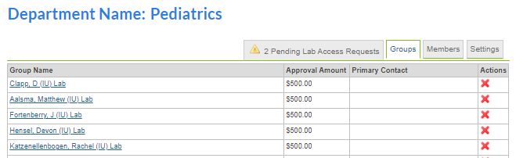
  - To add a group, scroll to the bottom of the Groups tab, enter the PI name in the search box, and click the Go button to search. Click the + Add button next to the appropriate group:
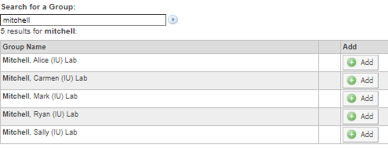
  - To remove a group, click the red X in the Actions column next to the group name.
- View Pending Lab Access Requests:
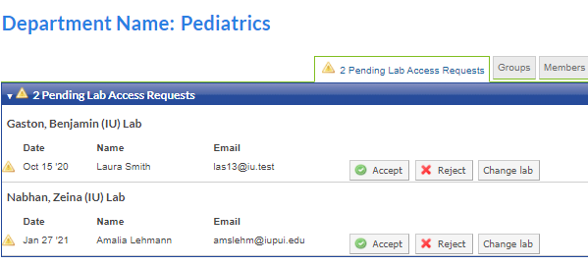
Requests to join any labs within the department will show up here. Department managers are able to view and approve these requests on behalf of the PI.
- Manage the department settings:
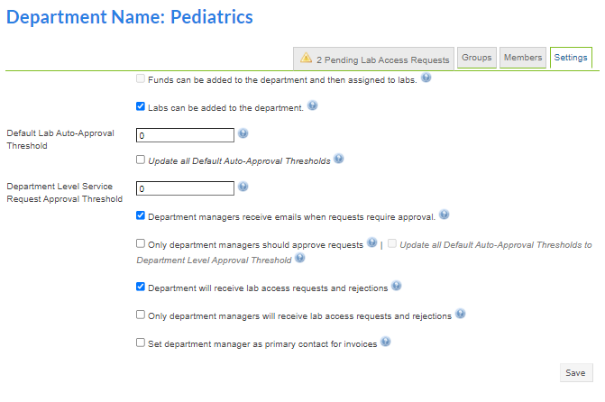

Approving Fund Requests

When a lab requests access to a fund the request will route to the iLab Fund Owner for approval. The iLab fund owner is the KFS Account Manager for C&G accounts (usually the PI) and the KFS Fiscal Officer for non-C&G accounts. The fund owner will receive an email from iLab with a direct link to view and approve/disapprove the request. Requests can also be viewed by navigating to View Funds in the iLab menu.
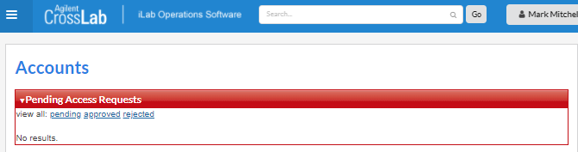
From here you can view any fund requests pending your approval and choose to approve or reject the request.

Understanding iLab Emails

As an iLab group/department manager you will receive a number of iLab emails. Common emails include:

- Subject: [External] iLab: NAME has requested access to Account: XXXXXXX-
  - You will receive this email if you are the fund owner of an account number that has been requested in a lab. You can also view the request from the View Funds link in the iLab menu.
  - Note. The name is listed in the subject line is the name of the person who submitted the request, not the name of the lab the account is being added to. To view the details of the lab needing access click the link in the email to view the request and approve or reject.
- Subject: [External] iLab: Your Account access request has been approved (or rejected).
  - You will receive this email if you submitted a request to add an account to a lab. The email will have a direct link to the accounts page of the lab so you can then assign the fund to lab members.
- Subject: [External] NAME is requesting access to Lab Name in iLab
  - You will receive this email if you are a PI, Lab Manager, or Department Manager of lab and a user is requesting to join the lab. The email will have a link to view and approve the request. You can also view the request from the lab or department page in iLab.
- Subject: [External] ACTION REQUIRED: Please provide financial approval for a request made by NAME from CORE
  - You will receive this email if you are a PI, financial manager, or department manager for a group and a service request has exceeded the auto-approval threshold. The email will provide a link to view the service request and provide financial approval.
- [External] NOTIFICATION: NAME The Service request SERVICE ID has been completed
  - You will receive this notification when a service request has been completed and is ready to bill for a lab for which you are the PI, financial manager, or department manager. You can click the link to view the completed service.
- [External] NOTIFICATION: A service request made by NAME from CORE has gone over the agreed cost
  - You will receive this notification if you are a PI, financial manager, or department manager for a group/lab and a service being billed to that lab has gone over the agreed upon cost. If the total cost is still under the auto-approval threshold this email will be a notification only. If the total cost is over the auto-approval threshold then the project will need financial approval before it can proceed.

