NASH: Nutrition, Activity, Sleep, and Hydration
Small steps to getting back on track

Mental and physical health are nearly inseparable, and our brains can’t function at their best when our bodies are not well taken care of. When we go through a period of feeling low on energy–whatever the root cause may be–it’s more difficult to do the things that make us feel good. We can get tired, become less active, pay less attention to what we eat, sleep too much or not enough, withdraw from our friends and family, and get less enjoyment out of our hobbies and activities than we used to.

This can quickly become a negative cycle, and often feels hard to break out of. If we don’t have enough energy to do the things that give us energy, we start running on empty:
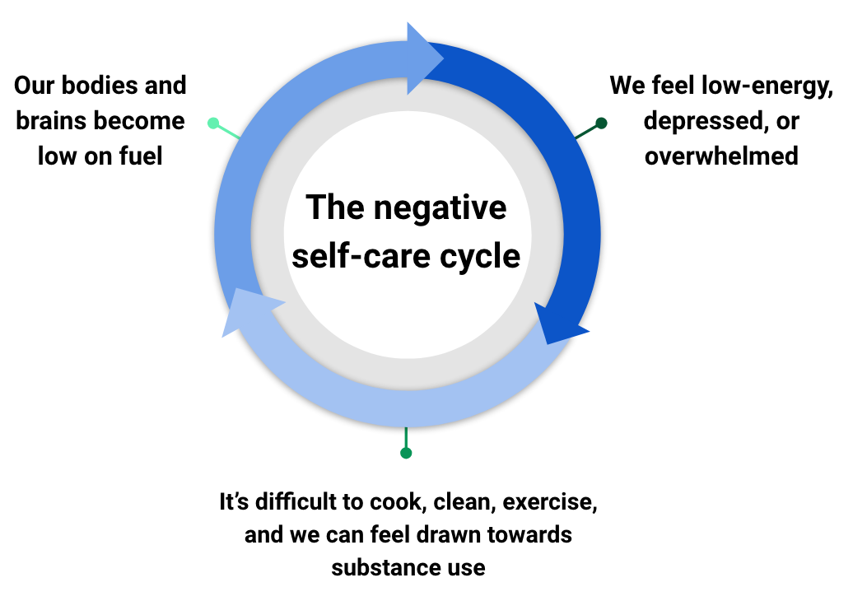

If this sounds familiar, you are not alone: the most recent cycle of the National Health and Nutrition Examination Survey¹ found that only 20% of respondents met national standards for “healthy behaviors'' in 4 out of 5 measured domains.

Many of us have some idea about the things we “should” be doing, but they’re typically described as broad, all-or-nothing accomplishments: exercise, eat well, get enough sleep, and so on. The concepts are simple, but we’re not often taught what specific steps we can take towards these goals.

This guide is meant to help outline some ways to specifically and slowly build–or rebuild–positive health habits, whether for ourselves or when counseling patients. We’ll briefly break down each of the four core areas of nutrition, activity, sleep, and hydration into smaller, more manageable goals as well as examine the research-supported benefits these add to our mental health.

Doing what we can: winning our smallest possible victories

We all know that drinking water, being active, eating well, and getting enough sleep will not magically solve all of our mental health challenges, but there is extensive research showing that the impact is not small:

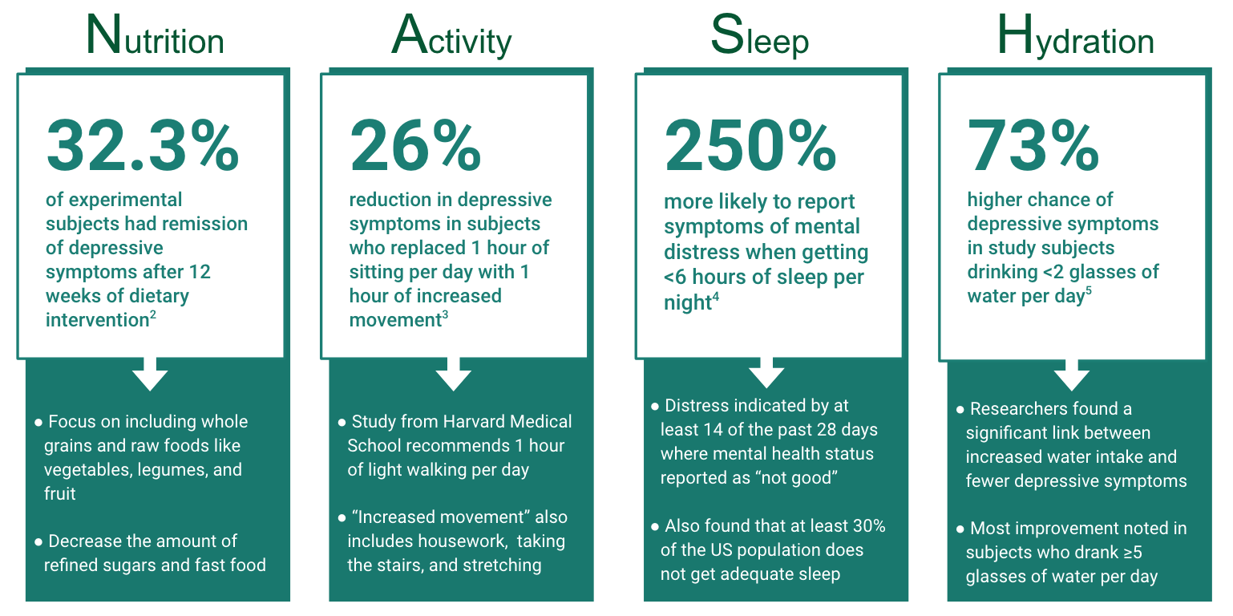
The goal is to take small steps towards our goals when we can, and to start filling our tank back up little by little. In his book Atomic Habits, author James Clear outlines ways to break down goals into the smallest possible steps. Instead of looking at one large, overwhelming task we make it smaller, easier, and less intimidating. This helps to address the number one difficulty most people have with accomplishing their goals: getting started.

One example is the goal of jogging twice per week: Clear advises that on the first day you want to go jogging, just put your shoes on. The next time, put your shoes on and walk outside. The third time you add on walking fifteen feet and back, and so on. Even though the scale starts small, Clear’s point is that getting yourself used to doing something consistently is the key to long-term behavior change.

This way of thinking works together with the concept of seizing opportunities as they naturally come up, especially if you have less time to take out of your day. Researchers estimate that we make over 220 decisions per day just about food. Instead of focusing on fixing all of them at once, try to improve one or two per day and they quickly add up.

Here are some examples of small opportunities to make changes:
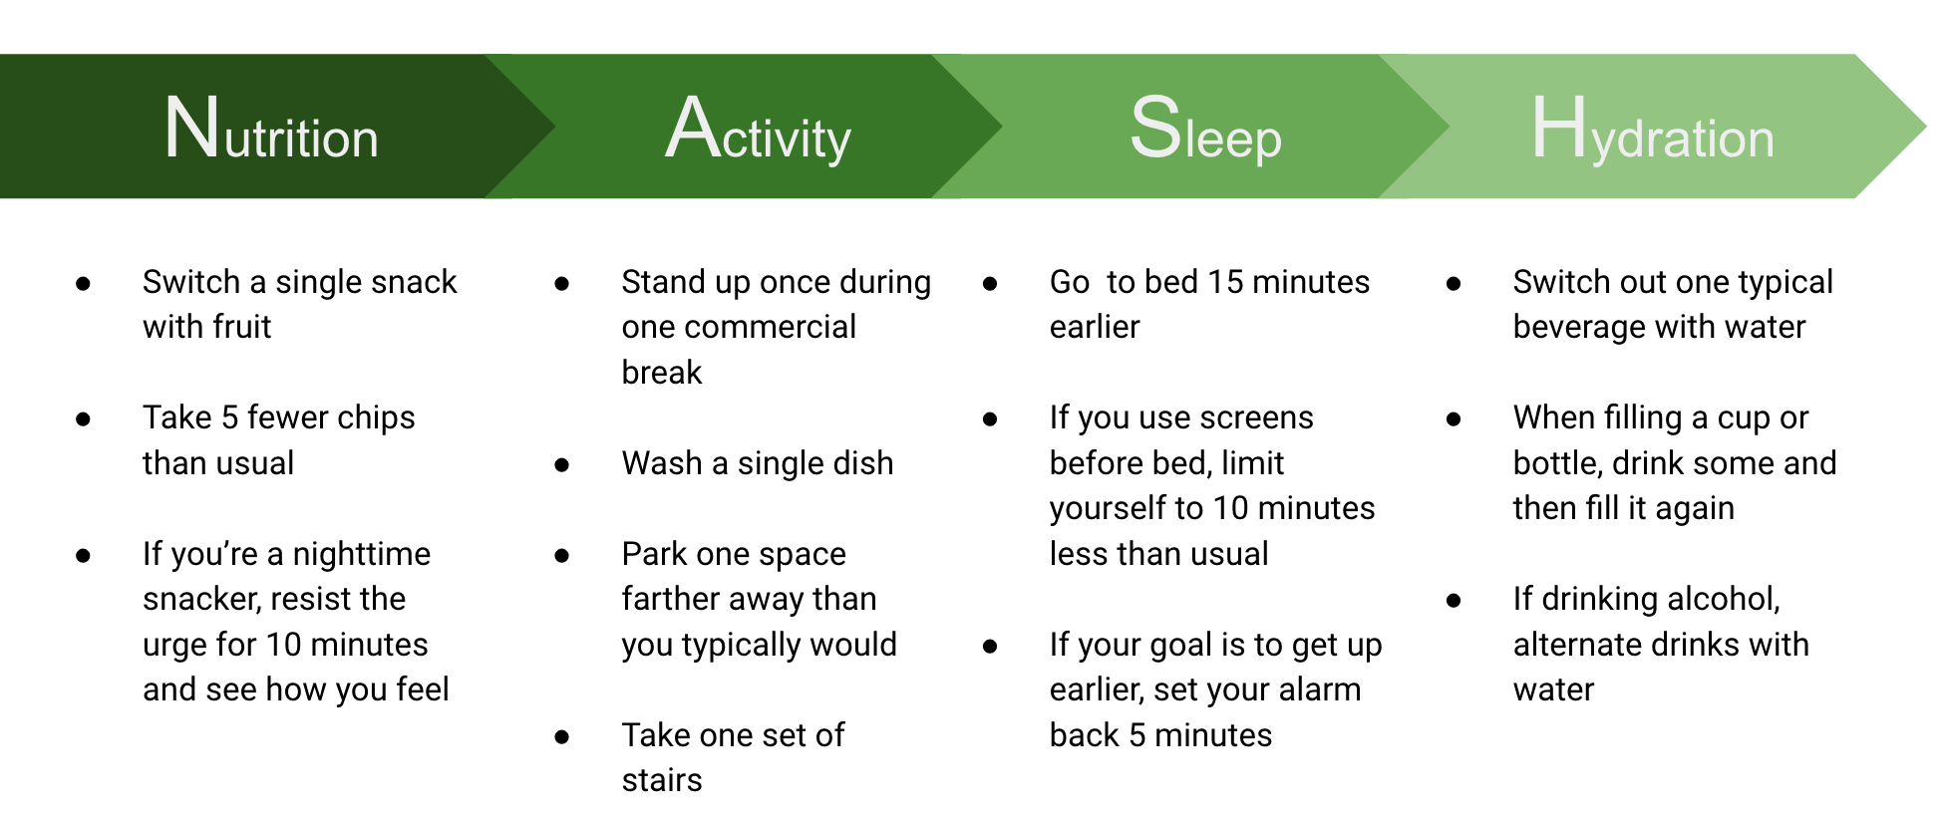
When trying out these techniques, be sure to give credit where credit is due. One way of staying motivated is by allowing ourselves to feel proud of our accomplishments, however small they may be. The goal is to make sustainable changes where we can over time:

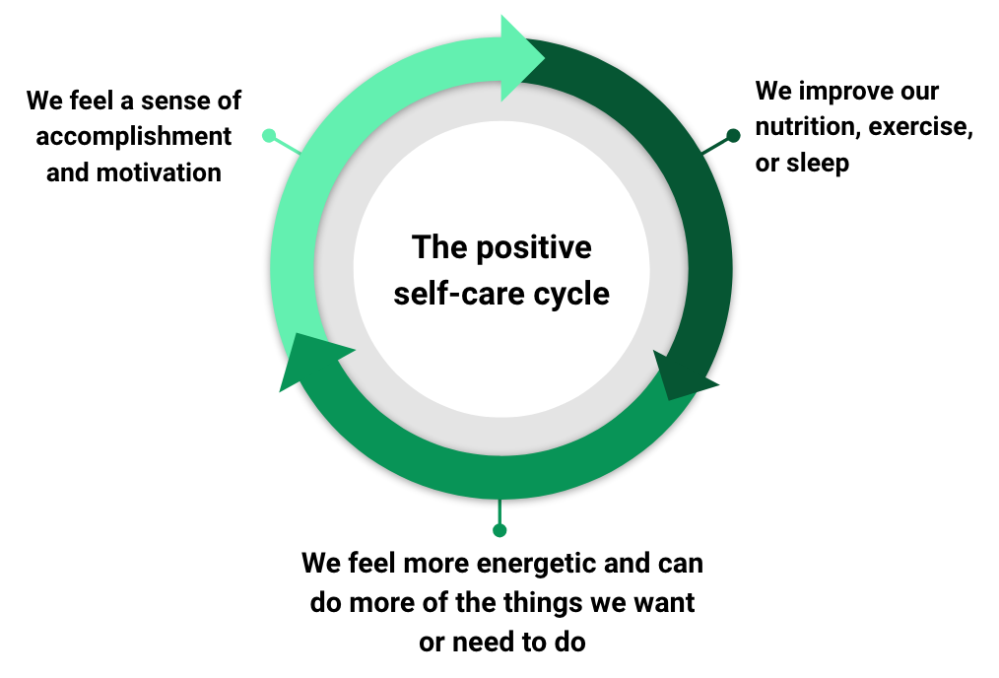

Remember, the goal is to start with small, realistic goals: these concepts should be adapted to fit whatever level is safe and reasonable for one’s own circumstances and individual level of ability. Excitement can often lead us to try too much at once, and there is a danger of burning ourselves out. We all face different challenges in pursuit of our own health, but we all have control over how we choose to improve it.

Sources:
- https://jamanetwork.com/journals/jamanetworkopen/fullarticle/2807257
- https://bmcmedicine.biomedcentral.com/counter/pdf/10.1186/s12916-017-0791-y.pdf
- https://www.health.harvard.edu/mind-and-mood/more-evidence-that-exercise-can-boost-mood
- https://www.ncbi.nlm.nih.gov/pmc/articles/PMC8220958/#:~:text=Participants%20who%20averaged%206%20hours,slept%20more%20than%206%20hours
- https://www.ncbi.nlm.nih.gov/pmc/articles/PMC6147771/

